Tiếng Anh 6 Unit 1 Towns and buildings

Tuần 5-Tiết 3 – 03-08/10/2022

Bài tập

I. Complete the table with the given words.

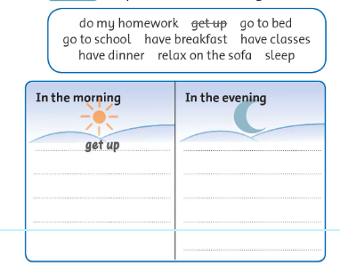

II. **Look at the pictures and complete the sentences with the given words.**

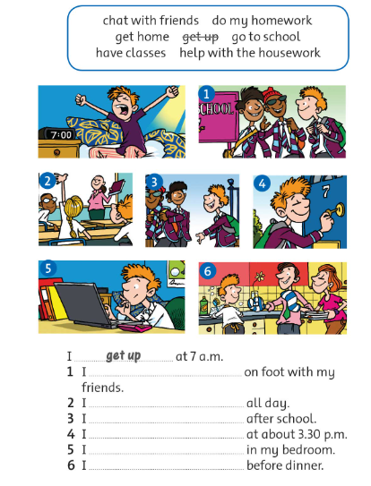

III. Choose the correct answer.

